2D Game Project

I’ve decided I’m going to clone the Google dinosaur game; it’s not going to get any less simple than that. Although I’m thinking the dinosaur and cactuses will resemble the cube and spikes from Geometry Dash a little bit, just more simple.
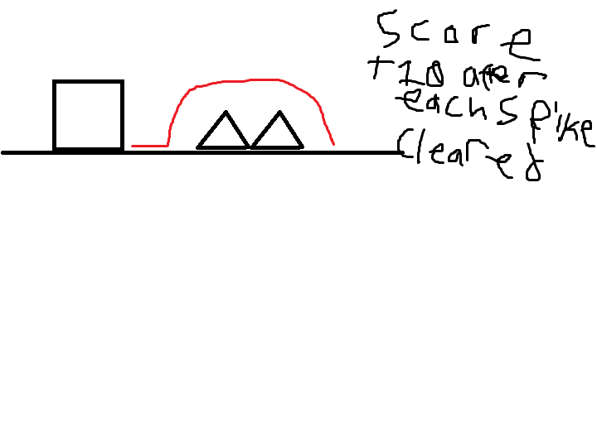
This is how I envision the game, it’s just very simple. Every spike you jump over successfully adds 10 points. The game will end if you hit the spikes even once, it’s really just a test of endurance.
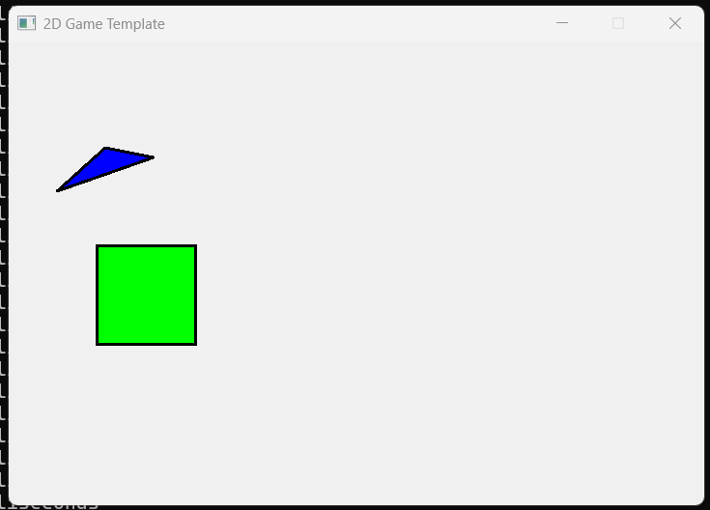
I just started figuring out how to get the graphics I wanted on the screen, after half an hour, I got them to look the way I wanted.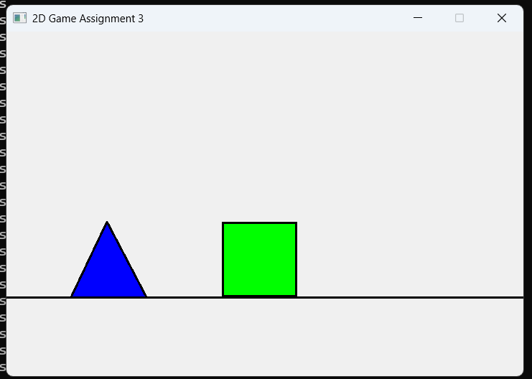
However, I ran into a problem: I can’t move the shapes at all. I defined an x and y for each draw function (and I used functions since I plan to spawn more spikes as the game progresses and I thought this would make it easier), however I’m having trouble getting the spike to move. I plan on getting the spike to move first since I plan on having the cube’s x position stay, but the spikes come to you, giving you a constant screen scrolling effect and I want to do that first so I can worry about trying to get the cube to jump (changing their y position) later.

